Part V: Real-World Campus Design and Implementation
Chapter 14 Campus Design Models
Chapter 15 Campus Design Implementation
Chapter 16 Troubleshooting
Chapter 17 Case Studies: Implementing Switches
Chapter 18 Layer 3 Switching and the Catalyst 6000/6500s

Chapter 14. Campus Design Models
This chapter covers the following key topics:
- Changing Traffic Patterns—
The rise of client/server computing, server farms, and Internet-based technology has dramatically changed most campus traffic patterns. This chapter looks at some of the challenging issues that this has created for campus network designers.
- Campus Design Terminology—
Explains IDF/MDF and access/distribution/core terminology, the two most common ways of explaining and discussing campus designs.
- Key Requirements of Campus Designs—
Looks at the attributes of the ideal campus design.
- Advantages of Routing—
The recommended approach to campus design makes extensive use of Layer 3 switching (routing) technology. The important benefits of this approach are discussed.
- Campus Design Models—
Three of the most common campus design models are discussed: the router and hub model, the campus-wide VLANs model, and the multilayer model.
- General Recommendation: Multilayer Model—
Some specific considerations and issues associated with the multilayer model, the recommended approach to campus design, are discussed.
- Distribution Blocks—
Discusses issues related to distribution blocks (usually a set of switches contained within a single building) for the multilayer design model.
- Core—
Explains issues related to designing a core for a multilayer network.
This chapter looks at several important models that can be used for campus designs. The discussion begins with a look at two sets of terminology used to describe and discuss network designs. Then, the three main approaches to campus design are presented:
- First, the traditional router and hub model is covered. Although this design is not suitable for use in modern campus networks, the proven advantages of this design are highlighted.
- Second, the chapter discusses the campus-wide VLANs or "flat earth" design. This is the design most people think of when the subject of a switched campus network comes up. Although it can be very useful for certain requirements, in general, it has many drawbacks and downsides.
- Third, the multilayer model is presented. This model is designed to blend Layer 2 and Layer 3 processing into a cohesive whole. The last half of the chapter elaborates on some issues that are specific to the multilayer architecture.
Whereas this chapter focuses on overall design architectures and paradigms, Chapter 15, "Campus Design Implementation," looks at specific strategies associated with campus designs. For example, this chapter points out the advantages of the multilayer model for the Spanning-Tree Protocol (STP), and Chapter 15 discusses STP best practices and makes specific STP recommendations.
Finally, please note that the intent of this chapter is not to create a survey of every campus design ever conceived. Instead, this text is oriented toward the design process. It explores several of the more popular and widely applicable designs in an attempt to discuss good design practices, as well as the pros and cons of various approaches to campus design.

Changing Traffic Patterns
Any effective campus design must take traffic patterns into account. Otherwise, switching and link bandwidth are almost certainly wasted. The good news is that most modern campus networks follow several trends that create unmistakable flows. This section discusses the traditional campus traffic patterns and shows how popular new technologies have drastically changed this.
The earliest seeds of today's campus networks began with departmental servers. In the mid-1980s, the growth of inexpensive PCs led many organizations to install small networks utilizing Ethernet, ArcNet, Token Ring, LocalTalk, and a variety of proprietary solutions. Many of these networks utilized PC-based server platforms such as Novell's Netware. Not only did this promote the sharing of information, it allowed expensive hardware such as laser printers to be shared.
Throughout the late-1980s, these small networks began to pop up throughout most corporations. Each network was built to serve a single workgroup or department. For example, the finance department would have a separate network from the human resources department. Most of these networks were extremely decentralized. In many cases, they were installed by non-technical people employed by the local workgroup (or outside consultants hired by the workgroup). Although some companies provided centralized support and guidelines for deploying these departmental servers, few companies provided links between these pockets of network computing.
In the early 1990s, multiprotocol routers began to change all of this. Routers suddenly provided the flexibility and scalability to begin hooking all of these "network islands" into one unified whole. Although routers allowed media-independent communication across the many different types of data links deployed in these departmental networks, Ethernet and Token Ring became the media of choice. Routers were also used to provide seamless communication across wide-area links.
Early routers were obviously extremely bandwidth-limited compared to today's products. How then did these networks function when the Gigabit networks of today strain to keep up? There are two main factors: the quantity of traffic and the type of traffic.
First, there was considerably less traffic in campus networks at the time early router-based campus networks were popular. Simply put, fewer people used the network. And those who did use it tended to use less network-intensive applications.
However, this is not to say that early networks were like a 15-lane highway with only three cars on it. Given the lower available bandwidth of these networks, many had very high average and peak utilization levels. For instance, before the rise of client/server computing, many databases utilized file servers as a simple "hard drive at the end of a long wire." Thousands of dBase and Paradox applications were deployed that essentially pulled the entire database across the wire for each query. Therefore, although the quantity of traffic has grown dramatically, another factor is required to explain the success of these older, bandwidth-limited networks.
To explain this difference, the type of traffic must be considered. Although central MIS organizations used routers and hubs to merge the network into a unified whole, most of the traffic remained on the local segment. In other words, although the networks were linked together, the workgroup servers remained within the workgroups they served. For example, a custom financial application developed in dBase needed to use only the finance department's server; it never needed to access the human resource server. The growing amount of file and printer server traffic also tended to follow the same patterns.
These well-established and localized traffic flows allowed designers to utilize the popular 80/20 rule. Eighty (or even 90+) percent of the traffic in these networks remained on the local segment. Hubs (or possibly early "switching hubs") could support this traffic with relative ease. Because only 20 (or even less than 10) percent of the traffic needed to cross the router, the limited performance of these routers did not pose significant problems.
With blinding speed, all of this began to change in the mid-1990s. First, enterprise databases were deployed. These were typically large client/server systems that utilized a small number of highly centralized servers. On one hand, this dramatically cut the amount of traffic on networks. Instead of pulling the entire database across the wire, the application used technologies such as Structured Query Language (SQL) to allow intelligent database servers to first filter the data before it was transmitted back to the client. In practice, though, client/server systems began to significantly increase the utilization of network resources for a variety of reasons. First, the use of client/server technology grew at a staggering rate. Although each query might only generate one fourth of the traffic of earlier systems, many organizations saw the number of transactions increase by a factor of 10–100. Second, the centralized nature of these applications completely violated the 80/20 rule. In the case of this traffic component, 100 percent needs to cross the router and leave the local segment.
Although client/server applications began to tax traditional network designs, it took the rise of Internet and intranet technologies to completely outstrip available router (and hub) capacity. With Internet-based technology, almost 100 percent of the traffic was destined to centralized servers. Web and e-mail traffic generally went to a small handful of large UNIX boxes running HTTP, Simple Mail Transfer Protocol (SMTP), and Post Office Protocol (POP) daemons. Internet-bound traffic was just as centralized because it needed to funnel through a single firewall device (or bank of redundant devices). This trend of centralization was further accelerated with the rise of server farms that began to consolidate workgroup servers. Instead of high-volume file and print server traffic remaining on the local wire, everything began to flow across the corporate backbone.
As a result, the traditional 80/20 rule has become inverted. In fact, most modern networks have less than five percent of their traffic constrained to the local segment. When this is combined with the fact that these new Internet-based technologies are wildly popular, it is clear that the traditional router and hub design is no longer appropriate.
Tip
Be sure to consider changing traffic patterns when designing a campus backbone. In doing so, try to incorporate future growth and provide adequate routing performance.

Campus Design Terminology
This section explains some of the terminology that is commonly used to describe network designs. The discussion begins with a review of the Intermediate Distribution Frame/Main Distribution Frame (IDF/MDF) terminology that has been borrowed from the telephone industry. It then looks at a three-level paradigm that can be very useful.

IDF/MDF
For years, the telephone industry has used the terms Intermediate Distribution Frame (IDF) and Main Distribution Frame (MDF) to refer to various elements of structured cabling. As structured cabling has grown in popularity within data-communication circles, this IDF/MDF terminology has also become common.
The following sections discuss some of the unique requirements of switches placed in IDF and MDF closets. In addition to these specialized requirements, some features should be shared across all of the switches. For new installations, all of the switches should offer a wide variety of media types that include the various Ethernet speeds and ATM. FDDI and Token Ring support can be important when migrating older networks. Also, because modern switched campus infrastructures are too complex for the "plug-it-in-and-forget-it" approach, comprehensive management capabilities are a must.

IDF
IDF wiring closets are used to connect end-station devices such as PCs and terminals to the network. This "horizontal wiring" connects to wall-plate jacks at one end and typically consists of unshielded twisted-pair (UTP) cabling that forms a star pattern back to the IDF wiring closet. As shown in Figure 14-1, each floor of a building generally contains one or more IDF switches. Each end station connects back to the nearest IDF wiring closet. All of the IDFs in a building generally connect back to a pair of MDF devices often located in the building's basement or ground floor.

Figure 14-1 Multiple IDF Wiring Closets
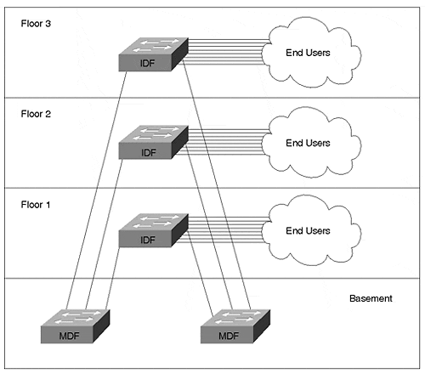
Given the role that they perform, IDF wiring closets have several specific requirements:
- Port density—
Because large numbers of end stations need to connect to each IDF, high port density is a must.
- Cost per port—
Given the high port density found in the typical IDF, cost per port must be reasonable.
- Redundancy—
Because several hundred devices often connect back to each IDF device, a single IDF failure can create a significant outage.
- Reliability—
This point is obviously related to the previous point, however, it highlights the fact that an IDF device is usually an end station's only link to the rest of the world.
- Ease of management—
The high number of connections requires that per-port administration be kept to a minimum.
Because of the numerous directly connected end users, redundancy and reliability are critical to the IDF's role. As a result, IDFs should not only utilize redundant hardware such as dual Supervisors and power supplies, they should have multiple links to MDF devices. Fast failover of these redundant components is also critical.
IDF reliability brings up an interesting point about end-station connections. Outside of limited environments such as financial trading floors, it is generally not cost-effect to have end stations connected to more than one IDF device. Therefore, the horizontal cabling serves as a single point of failure for most networks. However, note that these failures generally affect only one end station. This is several orders of magnitude less disruptive than losing an entire switch. For important end stations such as servers, dual-port network interface cards (NICs) can be utilized with multiple links to redundant server farm switches.
The traditional device for use in IDF wiring closets is a hub. Because most hubs are fairly simple devices, the price per port can be very attractive. However, the shared nature of hubs obviously provides less available bandwidth. On the other hand, routers and Layer 3 switches can provide extremely intelligent bandwidth sharing decisions. On the downside, these devices can be very expensive and generally have limited port densities.
To strike a balance between cost, available bandwidth, and port densities, almost all recently deployed campus networks use Layer 2 switches in the IDF. This can be a very cost-effective way to provide 500 or more end stations with high-speed access into the campus backbone.
However, this is not to say that some Layer 3 technologies are not appropriate for the wiring closet. Cisco has introduced several IDF-oriented features that use the Layer 3 and 4 capabilities of the NetFlow Feature Card (NFFC). As discussed in Chapter 5, "VLANs," and Chapter 11, "Layer 3 Switching," Protocol Filtering can be an effective way to limit the impact of broadcasts on end stations. By allowing a port to only output broadcasts for the Layer 3 protocols that are actually in use, valuable CPU cycles can be saved. For example, a broadcast-efficient TCP/IP node in VLAN 2 can be spared from being burdened with IPX SAP updates. IGMP Snooping is another feature that utilizes the NFFC to inspect Layer 3 information. By allowing the Catalyst to prune ports from receiving certain multicast addresses, this feature can save significant bandwidth in networks that make extensive use of multicast applications. Finally, the NFFC can be used to classify traffic for Quality of Service/Class of Service (QoS/COS) purposes.
Tip
The most important IDF concerns are cost, port densities, and redundancy.

MDF
IDF devices collapse back to one or more Main Distribution Frame (MDF) devices in a star-like fashion. Each IDF usually connects to two different MDF devices to provide adequate redundancy. Some organizations place both MDF devices in the same physical closet and rely on disparate routing of the vertical cabling for redundancy. Other organizations prefer to place the MDF devices in separate closets altogether. The relationship between buildings and MDFs is not a hard rule—larger buildings might have more than two MDF switches, whereas a pair of redundant MDF devices might be able to carry multiple buildings that are smaller in size.
Figure 14-2 shows three buildings with MDF closets. To meet redundancy requirements, each building generally houses two MDF devices. The MDF devices can also be used to interconnect the three buildings (other designs are discussed later).

Figure 14-2 MDF Closets
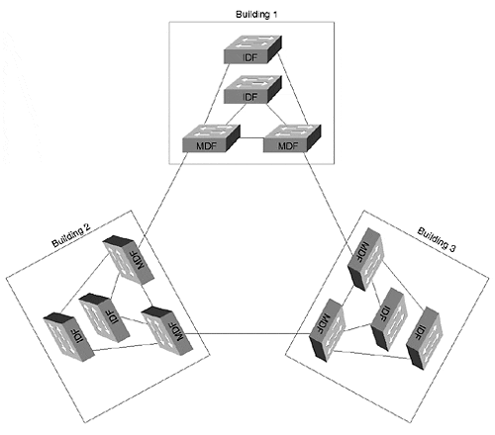
MDF closets have a different set of requirements and concerns than IDF closets:
- Throughput
- High availability
- Routing capabilities
Given that they act as concentration points for IDF traffic, MDF devices must be able to carry extremely high levels of traffic. In the case of a Layer 2 switch, this bandwidth is inexpensive and readily available. However, as is discussed later in this chapter, many of the strategies to achieve robust and scalable designs require routing in the MDF. Achieving this level of Layer 3 performance can require some careful planning. For more information on Layer 3 switching, see Chapter 11. Issues associated with Layer 3 switching are also addressed later in this chapter and in Chapter 15.
High availability is an important requirement for MDF devices. Although the failure of either an MDF or IDF switch potentially affects many users, there is a substantial distinction between these two situations. As discussed in the previous section, the failure of an IDF device completely disables the several hundred attached end stations. On the other hand, because MDFs are almost always deployed in pairs, failures rarely result in a complete loss of connectivity. However, this is not to say that MDF failures are inconsequential. To the contrary, MDF failures often affect thousands of users, many more than with an IDF failure. This requires as many features as possible that transparently reroute traffic around MDF problems.
In addition to the raw Layer 3 performance discussed earlier, other routing features can be important in MDF situations. For example, the issue of what Layer 3 protocols the router handles can be important (IP, IPX, AppleTalk, and so forth). Routing protocol support (OSPF, RIP, EIGRP, IS-IS, and so on) can also be a factor. Support for features such as DHCP relay and HSRP can be critical.
Three types of devices can be utilized in MDF closets:
- Layer 2 switches
- Hybrid, "routing switches" such as MLS
- "Switching routers" such as the Catalyst 8500
The first of these is also the simplest—a Layer 2 switch. The moderate cost and high throughput of these devices can make them very attractive options. Examples of these devices include current Catalyst 4000 models and traditional Catalyst 5000 switches without a Route Switch Module (RSM) or NFFC.
However, as mentioned earlier, there are compelling reasons to use Layer 3 processing in the MDF. This leads many network designs to utilize the third option, a Layer 3 switch that is functioning as a hardware-based router, what Chapter 11 referred to as a switching router. The Catalyst 8500 is an excellent example of this sort of device.
Cisco also offers another approach, Multilayer Switching (MLS), that lies between the previous two. MLS is a hybrid approach that allows the Layer 2-oriented Supervisors to cache Layer 3 information. It allows Catalysts to operate under the routing switch form of Layer 3 switching discussed in Chapter 11. A Catalyst 5000 with an RSM and NFFC is an example of an MLS switch. Other examples include the Catalyst 5000 Route Switch Feature Card (RSFC) and the Catalyst 6000 Multilayer Switch Feature Card (MSFC).
Note
It is important to understand the differences between the routing switch (MLS) and switching router (Catalyst 8500) styles of Layer 3 switching. These concepts are discussed in detail in Chapter 11.

Although the switching router (8500) and routing switch (MLS) options both offer very high throughput at Layer 3 and/or 4, there are important differences. For a thorough discussion of the technical differences, please see Chapter 11. This chapter and Chapter 15 focus on the important design implications of these differences.
Tip
The most important MDF factors are availability and Layer 3 throughput and capabilities.

Three-Layer Campus Network Model: Access, Distribution, Core
The IDF/MDF terminology discussed in the previous section describes the world in terms of two layers. However, MDF interconnections can often be better described with a third layer. For this reason, it is often useful to describe campus (and WAN) networks in terms of a three-layer model that more accurately describes the unique requirements of the inter-MDF connections. Geoff Haviland's excellent Cisco Internetwork Design (CID) course has popularized the use of the terms access, distribution, and core to describe these three layers. Figure 14-3 illustrates the three-layer model.

Figure 14-3 The Three-Layer Design Model
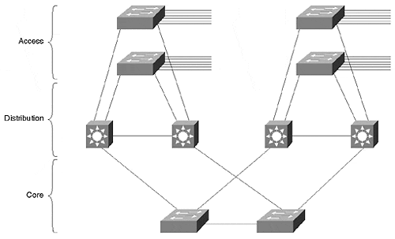
Each of these layers is briefly discussed in the following three sections.

Access Layer
The IDF closets are termed access layer closets under the three-layer model. The idea is that the devices deployed in these closets should be optimized for end-user access. Access layer requirements here are the same as those discussed in the IDF section: port density, cost, resiliency, and ease of management.

Distribution Layer
Under the three-layer model, MDF devices become distribution layer devices. The requirement for high Layer 3 throughput and functionality is especially important here.
Tip
In campus networks, the term access layer is synonymous with IDF, and distribution layer is equivalent to MDF.

Core Layer
The connections between the MDF switches become the core layer under the three-layer model. As is discussed in detail later, some networks have a very simple core consisting of several inter-MDF links or a pair of Layer 2 switches. In other cases, the size of the network might require Layer 3 switching within the core. Many networks utilize an Ethernet-based core; others might use ATM technology.
Note
In general, the terms access layer and distribution layer are used interchangeably with IDF and MDF. However, the IDF/MDF terms are used most often when discussing two-layer network designs; the access/distribution/core terminology is used when explaining three-layer topologies.

Key Requirements of Campus Designs
The "ideal" campus network should strive to achieve certain objectives. Some of these aspects have already been mentioned, but several new and important issues are introduced here (the new points are mentioned first):
- Load balancing—
Given redundant paths, load balancing allows you to utilize all of the bandwidth you paid for. As is discussed in more detail in Chapter 15, flexibility, intelligence, and ease of configuration can be critical factors when utilizing this important feature.
- Deterministic traffic patterns—
Traffic that flows in predictable ways can be crucial to network performance and troubleshooting. This can be especially true during network failure and recovery situations.
- Consistent number of hops—
One of the principle factors contributing to deterministic traffic flows is a consistent number of hops throughout the network. As is discussed later in the chapter, this can best be achieved through a modular and consistent design.
- Ease of configuration—
The network should not be excessively difficult to initially configure.
- Ease of maintenance—
Ongoing maintenance tasks should be minimized. Where required, the tasks should follow well-established patterns that allow "cookie cutter" configurations.
- Ease of troubleshooting—
Some designs can appear extremely appealing on paper, but they are a nightmare to troubleshoot (for example, extremely flat networks). A good design utilizes scalable modules or building blocks to promote easy troubleshooting through consistency and predictability.
- Redundancy—
A 10–20 percent increase in hardware costs can increase network reliability by several hundred percent.
- Cost—
Cost per port is especially important for high-density IDF devices.

Advantages of Routing
One of the key themes that is developed throughout this chapter is the idea that routing is critical to scalable network design. Hopefully, this is not news to you. However, given the recent popularity and focus on extremely flat, "avoid-the-router" designs, a fair amount of attention is devoted to this subject. Many people are convinced that the key objective in campus network design is to eliminate as many routers as possible. On the contrary, my experience suggests that this is exactly the wrong aim—routers have a proven track record of being the key to achieving the requirements of campus design discussed in the previous section.
- Scalable bandwidth—
Routers have traditionally been considered slower than other approaches used for data forwarding. However, because a routed network uses a very decentralized algorithm, higher aggregate rates can be achieved than with less intelligent and more centralized Layer 2 forwarding schemes. Combine this fact with newer hardware-based routers (Layer 3 switches) and routing can offer extraordinary forwarding performance.
- Broadcast filtering—
One of the Achilles heels of Layer 2 switching is broadcast containment. Vendors introduced VLANs as a partial solution to this problem, but key issues remain. Not only do broadcasts rob critical bandwidth resources, they also starve out CPU resources. Techniques such as ISL and LANE NICs that allow servers to connect to multiple VLANs in an attempt to build flat networks with a minimal use of routers only make this situation much worse—now the server must process the broadcasts for 10 or 20 VLANs! On the other hand, the more intelligent forwarding algorithms used by Layer 3 devices allow broadcasts to be contained while still maintaining full connectivity.
- Superior multicast handling—
Although progress is being made to improve multicast support for Layer 2 devices through schemes such as IGMP Snooping, CGMP, and 802.1p (see Chapter 13, "Multicast and Broadcast Services" ), it is extremely unlikely that these efforts will ever provide the comprehensive set of features offered by Layer 3. By running Layer 3 multicast protocols such as PIM, routers always provide a vast improvement in multicast efficiency and scalability. Given the predictions for dramatic multicast growth, this performance will likely be critical to the future (or current) success of your network.
- Optimal path selection—
Because of their sophisticated metrics and path determination algorithms, routing protocols offer much better path selection capabilities than Layer 2 switches. As discussed in the Spanning Tree chapters, Layer 2 devices can easily send traffic through many unnecessary bridge hops.
- Fast convergence—
Not only do routing protocols pick optimal paths; they do it very quickly. Modern Layer 3 routing protocols generally converge in 5–10 seconds. On the other hand, Layer 2 Spanning-Tree Protocol (STP) convergence takes 30–50 seconds by default. Although it is possible to change the default STP timers and to make use of optimizations such as UplinkFast in certain topologies, it is very difficult to obtain the consistently speedy results offered by Layer 3 routing protocols.
- Load balancing—
Routing protocols also have sophisticated load balancing mechanisms. Layer 3 load balancing is flexible, easy to configure, and supports many simultaneous paths. On the other hand, Layer 2 load balancing techniques such as the STP load balancing described in Chapter 7, "Advanced Spanning Tree," can be extremely c umbersome and difficult to use.
- Flexible path selection—
In addition to all of the other path selection benefits offered by routers, Cisco routers offer a wide variety of tools to manipulate path selections. Distribute lists, route maps, static routes, flexible metrics, and administrative distances are all examples of such mechanisms. These tools provide very granular control in a Layer 3 network.
- Summarized addressing—
Layer 2 addresses use a flat address space. There is nothing about a MAC address that indicates physical location (it is much like a Social Security number). As a result, every bridging table in a flat network must contain an address for every node. On the other hand, Layer 3 addresses indicate location much like a ZIP code (postal code) or a telephone number's area code. By allowing addresses to be summarized, this hierarchical approach can allow much larger networks to be built. As a result, forwarding tables not only shrink dramatically in size, the address learning or routing table update process becomes much easier. Finally, lookups in the forwarding tables can be much faster.
- Policy and access lists—
Most Layer 2 switches have very limited, if any, filtering capabilities. When filtering or access lists are supported, they use MAC addresses, hardly an efficient way to implement policy. On the other hand, routers can be used to provide complex access lists that function on Layer 3 and 4 information. This is much more useful from a policy implementation perspective. Hardware-based access lists are becoming increasingly common and flexible in Layer 3 switches.
- Value-added features—
Although it is unlikely that the switching router Layer 3 devices such as the Catalyst 8500 will support "high touch" WAN-oriented services such as DLSw+ and protocol translation, there are still a large number of extremely important features that are offered by these platforms. For example, technologies such as DHCP relay, proxy ARP, debug, and proxy GNS can be critical router-based features in campus networks. (Note that some Layer 3 platforms can perform "high touch" services by running them in software. For example, MLS using an RSM could do DLSw+ on the RSM. The native IP traffic uses the NFFC for wire-speed forwarding; the DLSw+ is dependent on slower software-based forwarding.)
Tip
Large networks almost always benefit from scalability, flexibility, and intelligence of routing. Try to build routing (Layer 3 switching) into your campus design.

Campus Design Models
Although a myriad of permutations and variations exist, most campus designs can be grouped into three categories:
- Traditional router and hub model
- Campus-wide VLANs model (also known as flat earth and end-to-end VLANs)
- Multilayer model
The sections that follow go into more detail on each of these campus design models.

Router and Hub Model
Figure 14-4 illustrates the traditional router and hub model.

Figure 14-4 Router and Hub Model
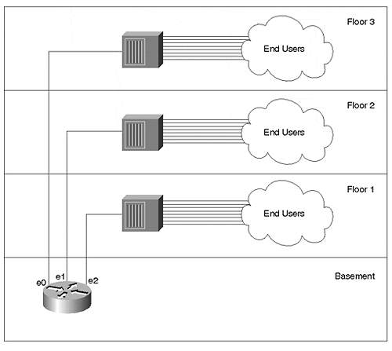
The traditional router and hub model uses Layer 1 hubs in IDF/access wiring closets. These connect back to unique ports on routers located in MDF/distribution closets. Several options are available for the campus core. In one approach, the distribution layer routers directly interconnect to form the network core/backbone. Because of its reliability and performance, an FDDI ring has traditionally been the media of choice for these connections. In other cases, some network designers prefer to form a collapsed backbone with a hub or router.
There are several advantages to the router and hub model as well as several reasons why most new designs have shied away from this approach. Table 14-1 lists the advantages and disadvantages of the router and hub model.

Table 14-1. Advantages and Disadvantages of the Router and Hub Model
Advantage | Disadvantage
Its reliance on routers makes for very good broadcast and multicast control. | Shared-media hubs do not offer enough bandwidth for modern applications. For example, in Figure 14-2, each floor must share a single 10 Megabit segment (factor in normal Ethernet overhead and these segments become extremely slow).
Because each hub represents a unique IP subnet or IPX network, administration is straightforward and easy to understand. | This design generally uses software-based routers that cannot keep up with increasing traffic levels.
Given moderate levels of traffic and departmental servers located on the local segment, the router and hub model can yield adequate performance. | Traffic patterns have changed, invalidating the assumption that most traffic would remain local. As a result, the campus-wide VLANs model became popular.
The hardware for this model is readily available and inexpensive.
The chief advantage of this approach is the simplicity and familiarity that it brings to campus network design and management. The primary disadvantage is the limited bandwidth that this shared-media approach offers. The multilayer design model discussed later attempts to capitalize on the simplicity of the router and hub model while completely avoiding the limited bandwidth issue through the use of Layer 2 and 3 switching technology.

Campus-Wide VLANs Model
As people began to notice their router and hub networks struggling to keep up with traffic demands, they looked for alternate approaches. Many of these organizations decided to implement campus-wide VLANs, also known as the flat earth and end-to-end VLAN approach to network design.
Campus-wide VLANs strive to eliminate the use of routers. Because routers had become a significant bottleneck in campus networks, people looked for ways to minimize their use. Because broadcast domains still needed to be held to a reasonable size, VLANs were used to create logical barriers to broadcasts. Figure 14-5 illustrates a typical campus-wide VLANs design.

Figure 14-5 Campus-Wide VLAN Model
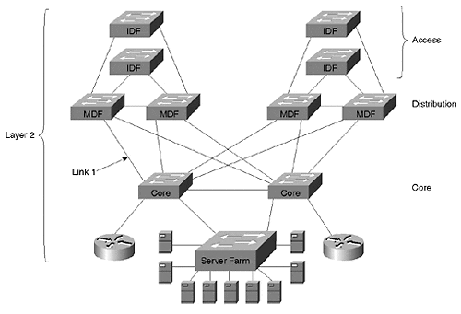
Figure 14-5 uses Layer 2 switching throughout the entire network. To provide communication between VLANs, two routers have been provided using the router-on-a-stick configuration (see Chapter 11).

Advantages of Campus-Wide VLANs
As the paragraphs that follow attest, there are some alluring aspects to the flat earth approach.
First, the campus-wide VLANs model allows network designers to create a direct Layer 2 path from end stations to the most commonly used servers. By deploying Layer 2 switching in all three layers of the access/distribution/core model, campus-wide VLANs should dramatically increase available bandwidth.
The second advantage of the campus-wide VLANs model is that VLANs can be used to provide logical control over broadcast domains and, therefore, subnets. Some platforms allow the switches to automatically detect what VLAN an end station should be assigned to, requiring no administration for adds, moves, and changes. Other schemes allow for more centralized control over VLAN assignments and strive to make the administration as easy as possible. For example, vendors can provide demos of glitzy products that allow you to drag-and-drop end users into VLANs. Other examples include Cisco's Virtual Management Policy Server (VMPS) that makes VLAN assignments based on MAC addresses and User Registration Tool (URT) that uses NT directory services (VMPS and URT are discussed in the section "VMPS and Dynamic VLANs: Advanced Administration" of Chapter 5, "VLANs" ).
The third advantage of campus-wide VLANs is that traffic only goes through a router if it needs to cross VLAN boundaries. If a user in the Finance VLAN needs to access the Finance server (located in the same VLAN), no routers are involved. However, if this user needs to occasionally access a server in the Marketing VLAN, a router is used. Servers can even be directly connected to multiple VLANs through the use of ISL or LANE NICs, further reducing the requirement for routers. For example, the server in the Marketing VLAN can be fitted with an ISL NIC to allow direct, Layer 2 access from the Finance VLAN.
Finally, this centralized use of routing can make it much easier to configure access lists and security in the network. For example, consider the case of a college network where two VLANs exist: students and professors. These two VLANs might span dozens of buildings, but because of the centralized routing typically used with campus-wide VLANs, access lists might only need to be configured on a pair of routers. On the other hand, if every building on campus connected to the campus backbone through a router, the network might require hundreds of access lists scattered across many dozens of routers.
The end result: you have the speed of Layer 2, the flexibility of VLANs, and you have avoided the "slowness" of the router.

Disadvantages of Campus-Wide VLANs
There are also some significant downsides to the campus-wide VLANs model:
- Management difficulties
- Lack of logical structure
- Large and overlapping Spanning Tree domains
- It is easy for a problem in one VLAN to deplete bandwidth in all VLANs across trunk links
- Many networks using campus-wide VLANs must resort toeliminating all redundancy to achieve network stability
- Lack of scalability
- Most modern traffic violates the "stay in one subnet" rule employed by the campus-wide VLAN model
- Modern routers are not a bottleneck
The paragraphs that follow provide more detailed coverage of each of these disadvantages.
Management of these networks can be much more difficult and tedious than originally expected. The router and hub design had the logical clarity of one subnet per wiring closet. Conversely, many networks using campus-wide VLANs have developed into a confusing mess of VLAN and Layer 3 address assignments.
Another downside to campus-wide VLANs is that the lack of logical structure can be problematic, especially when it comes to troubleshooting. Without a clearly defined hierarchy, it is very difficult to narrow down the source of each problem. Before each troubleshooting session, valuable time can be wasted trying to understand the constantly changing VLAN structure.
Also, campus-wide VLANs result in large and overlapping Spanning Tree domains. As discussed in Chapter 6, "Understanding Spanning Tree," and Chapter 7, "Advanced Spanning Tree," STP uses a complex set of evaluations that elect one central device (the Root Bridge) for every VLAN. Other bridges and switches then locate the shortest path to this central bridge/switch and use this path for all data forwarding. The Spanning-Tree Protocol is extremely dynamic—if the Root Bridge (or a link to the Root Bridge) is "flapping," the network continuously vacillates between the two switches acting as the Root Bridge (disrupting traffic every time it does so). Large Spanning Tree domains must use very conservative timer values, resulting in frustratingly slow failover performance. Also, as the size and number of the Spanning Tree domains grow, the possibility of CPU overload increases. If a single device in a single VLAN falls behind and opens up a loop, this can quickly overload every device connected to every VLAN. The result: network outages that last for days and are difficult to troubleshoot.
Yet another downside to campus-wide VLANs is that the wide use of trunk links that carry multiple VLANs makes the Spanning Tree problems even worse. For example, consider Link 1 in Figure 14-5, a Fast Ethernet link carrying VLANs 1–15. Assume that the CPU in a single switch in VLAN 1 becomes overloaded and opens up a bridging loop. Although the loop might be limited to VLAN 1, this VLAN's traffic can consume all of the trunk's capacity and starve out all other VLANs. This problem is even worse if you further assume that VLAN 1 is the management VLAN. In this case, the broadcasts caught in the bridging loop devour 100 percent of switch's CPU horsepower throughout the network. As more and more switch CPUs become overloaded, more and more VLANs experience bridging loops. Within a matter of seconds, the entire network "melts down."
An additional problem with the campus-wide VLAN model is that, to avoid these Spanning Tree and trunking problems, many campus-wide VLAN networks have had to resort to eliminating all redundant paths just to achieve stability. To solve this problem, redundant links can be physically disconnected or trunks can be pruned in such a way that a loop-free Spanning Tree is manually created. In either case, this makes every device in the network a single point of failure. Most network designers never intend to make this sort of sacrifice when they sign up for a flat earth design. Without routers, there are no Layer 3 "barriers" in the network and it becomes very easy for problems to spread throughout the entire campus.
Furthermore, campus-wide VLANs are not scalable. Many small networks have been successfully deployed using the campus-wide VLAN design. Initially, the users of these networks are usually very happy with both the utility and the bandwidth of their new infrastructure. However, as the network begins to grow in size, the previously mentioned problems become more and more chronic.
Yet another downside to campus-wide VLANs is that it is harder and harder to bypass routers, the very premise that the entire campus-wide VLANs scheme was built upon. As traffic patterns have evolved from departmental servers on the local segment to enterprise servers located in a centralized server farm, it has become very difficult to remove routers from this geographically dispersed path. For example, it can be difficult to connect an enterprise web server to 20 or more VLANs (subnets) without going through a router. A variety of solutions such as ISL, 802.1Q, and LANE NICs have become available; however, these have generally produced very disappointing performance. And, as mentioned earlier, these NICs request the server to process all broadcasts for all VLANs, robbing it of valuable and expensive CPU cycles. Also, the multiple-VLAN NICs have been fraught with other problems such as slow initialization time, a limited number of VLANs, and unexpected server behavior.
Finally, another basic premise of the campus-wide VLAN strategy is no longer true. Specifically, routers are now as fast (or nearly as fast) as Layer 2 switches. Although this equivalent performance generally comes at a price premium, it is no longer worthwhile to go to such great lengths to avoid Layer 3 routing.

Practical Advice Regarding Campus-Wide VLANs
I have implemented several networks utilizing the campus-wide VLAN approach. Prior to 1998, routers were simply too slow to place them in the middle of burgeoning campus traffic levels. Although I often had this nagging feeling about the lack of Layer 3 hierarchy, I jumped on the bandwagon with everyone else. In short, there simply didn't seem to be another option. However, with the advent of Layer 3 switching, I see fewer and fewer compelling uses for campus-wide VLANs.
Before leaving you with the feeling that everyone using campus-wide VLANs hates it, I should also point out that there are some fairly large networks utilizing this model with great success. Whether it is because their traffic patterns still adhere to the 80/20 rule or they like to take advantage of the drag-and-drop approach to VLANs, some network administrators firmly support this style of network design.
However, I have talked to far more clients that have struggled to produce stable and scalable networks using this model. For many users, the disadvantages discussed earlier are far too debilitating to justify the advantages of the campus-wide VLAN design.
Tip
Carefully evaluate the downsides of the campus-wide model before designing your network in this manner. Although some users are very happy with this approach to campus design, most have been disappointed with the stability and scalability.

Multilayer Model
The multilayer model strives to provide the stability and scalability of the router and hub model while also capturing the performance of the campus-wide VLANs model. This approach takes full advantage of hardware-based routing, Layer 3 switching, to put routing back into its rightful place. However, it does not ignore Layer 2 switching. In fact, it seeks to strike the optimal balance—Layer 3 switching is used for control, whereas Layer 2 switching is used for cost-effective data forwarding.
Figure 14-6 illustrates a sample network using the multilayer model.

Figure 14-6 Multilayer Model
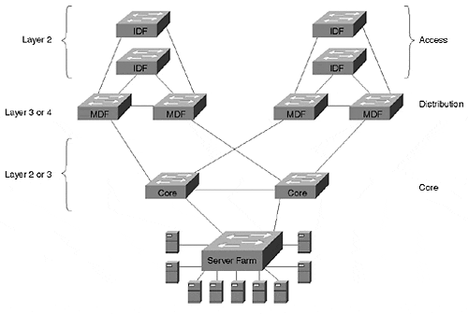
Each IDF/MDF cluster forms a separate module in the design. Figure 14-6 shows two modules. The access layer IDF switches use Layer 2 forwarding to provide large amounts of cost-effective bandwidth. The distribution layer MDF switches provide the Layer 3 control that is required in all large networks. These IDF/MDF modules then connect through a variety of Layer 2 or Layer 3 cores.
Tip
The multilayer model combines Layer 2 and Layer 3 processing into a cohesive whole. This design has proven to be highly flexible and scalable.

In general, the multilayer model is the recommended approach for enterprise campus design for several reasons.
First, the use of routers provides adequate Layer 3 control. In short, this allows all of the benefits discussed in the "Advantages of Routing" section to accrue to your network. Without listing all of these advantages again, a multilayer design is scalable, flexible, high performance, and easy to manage.
Second, as its name suggests, the multilayer model offers hierarchy. In hierarchical networks, layers with specific roles are defined to allow large and consistent designs. As the next section discusses, this allows each layer of the access/distribution/core model to meet unique and specific requirements.
Third, this approach is very modular. There are many benefits to a modular design, including the following:
- It is easy to grow the network.
- The total available bandwidth scales as additional modules are added.
- Modular networks are easier to understand, troubleshoot, and maintain.
- The network can use cookie cutter configurations. This consistency saves administrative headaches while also reducing the chance of configuration errors.
- It is easier to migrate to a modular network. The old network can appear as another module (although it does not have the consistent layout and configurations of modules in the new network).
- Modular networks allow consistent and deterministic traffic patterns.
- Modular designs promote load balancing and redundancy.
- It is much easier to provide fast failover in a consistent, modular design than it is in less structured designs. Because the topology is constrained and well defined, both Layer 2 and Layer 3 convergence benefit.
- Modular networks allow technologies to be easily substituted for one another. Not only does this allow organizations more freedom in the initial design (for example, the core can be either Ethernet or ATM), it makes it easier to upgrade the network in the long run.

General Recommendation: Multilayer Model
As discussed in the previous section, the multilayer model is the most appropriate approach for most modern campus networks for a variety of reasons. This section explains some specific considerations of this model.

Distribution Blocks
A large part of the benefit of the multilayer model centers around the concept of a modular approach to access (IDF) and distribution (MDF) switches. Given a pair of redundant MDF switches, each IDF/access layer switch forms a triangle of connectivity as shown in Figure 14-7. If there are ten IDF switches connected to a given set of MDF switches, ten triangles are formed (such as might be the case in a ten-story building). The collection of all triangles formed by two MDF switches is referred to as a distribution block. Most commonly, a distribution block equates to all of the IDF and MDF switches located in a single building.

Figure 14-7 Triangles of Connectivity within a Distribution Block
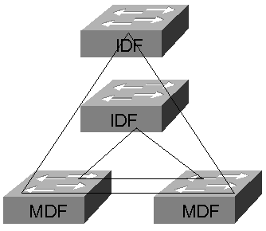
Because of its simplicity, the triangle creates the ideal building block for a campus network. By having two vertical links (IDF uplink connections), it automatically provides redundancy. Because the redundancy is formed in a predictable, consistent, and uncomplicated fashion, it is much easier to provide uniformly fast failover performance.
Tip
Use the concept of a distribution block to simplify the design and maintenance of your network.

The multilayer model does not take a dogmatic stance on Layer 2 versus Layer 3 switching (although it is based around the theme that some Layer 3 processing is a requirement in large networks). Instead, it seeks to create the optimal blend of both Layer 2 and Layer 3 technology to achieve the competing goals of low cost, high performance, and scalability.
To provide cost-effective bandwidth, Layer 2 switches are generally used in the IDF (access layer) wiring closets. As discussed earlier, the NetFlow Feature Card can add significant value in the wiring closet with features such as Protocol Filtering and IGMP Snooping.
To provide control, Layer 3 switching should be deployed in the MDF (distribution layer) closets. This is probably the single-most important aspect of the entire design. Without the Layer 3 component, the distribution blocks are no longer self-contained units. A lack of Layer 3 processing in the distribution layer causes Spanning Tree, VLANs, and broadcast domains to spread throughout the entire network. This increases the interdependency of various pieces of the network, making the network far less scalable and far more likely to suffer a network-wide outage.
By making use of Layer 3 switching, each distribution block becomes an independent switching system. The benefits discussed in the "Advantages of Routing" section are baked into the network. Problems that develop in one part of the network are prevented from spreading to other parts of the network.
You should also be careful to not circumvent the modularity of the distribution block concept with random links. For example, Links 1 and 2 in Figure 14-8 break the modularity of the multilayer model.

Figure 14-8 Links 1 and 2 Break the Modularity of the Multilayer Design
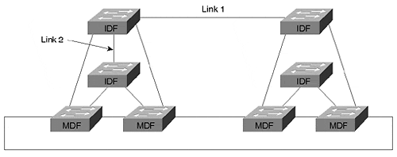
The intent here was good: provide a direct, Layer 2 path between three IDF switches containing users in the same workgroup. Although this does eliminate one or two router hops from the paths between these IDF switches, it causes the entire design to start falling apart. Soon another exception is made, then another, and so on. Before long, the entire network begins to resemble an interconnected mess more like a bowl of spaghetti than a carefully planned campus network. Just remember that the scalability and long-term health of the network are more important than a short-term boost in bandwidth. Avoid "spaghetti networks" at all costs.
Tip
Be certain to maintain the modularity of distribution blocks. Do not add links or inter-VLAN bridging that violate the Layer 3 barrier that the multilayer model uses in the distribution layer.

Without descending too far into "marketing speak," it is useful to note the potential application of Layer 4 switching in the distribution layer. By considering transport layer port numbers in addition to network layer addressing, Layer 4 switching can more easily facilitate policy-based networking. However, from a scalability and performance standpoint, Layer 4 switching does not have a major impact on the overall multilayer model—it still creates the all-important Layer 3 barrier at the MDF switches.
On the other hand, the choice of Layer 3 switching technology can make a difference in matters such as addressing and load balancing.

Switching Router (8500) MDFs
In the case of 8500-style switching routers, the MDF switches make a complete break in the Layer 2 topology by default. As a result, the triangles of connectivity appear as two unique subnets—one that crosses the IDF switch and one that sits between the MDF switches as illustrated in Figure 14-9.

Figure 14-9 Switching Router MDF Switches Break the Network into Two Subnets
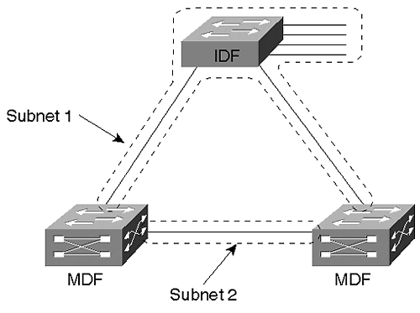
The resulting network is completely free of Layer 2 loops. Although some network designers have viewed this as an opportunity to completely disable the Spanning-Tree Protocol, this is generally not advisable because misconfiguration errors can easily create loops in the IDF wiring closet or end-user work areas (therefore possibly taking down the entire IDF). However, it does mean that STP load balancing cannot be used. Recall from Chapter 7 that STP load balancing requires two characteristics to be present in the network. First, it requires redundant paths, something that exists in Figure 14-9. Second, it requires that these redundant paths form Layer 2 loops, something that the routers in Figure 14-9 prevent. Therefore, some other load balancing technique must be employed.
Note
The decision of whether or not the Spanning-Tree Protocol should be disabled can be complex. This book recommends leaving Spanning Tree enabled (even in Layer 2 loop-free networks such as the one in Figure 14-9) because it provides a safety net for any loops that might be accidentally formed through the end-user ports. Currently, most organizations building large-scale campus networks want to take this conservative stance. This choice seems especially wise when you consider that Spanning Tree does not impose any failover delay for important topology changes such as a broken IDF uplink. In other words, the use of Spanning Tree in this environment provides an important benefit while having very few downsides.
For more discussion on the technical intricacies of the Spanning-Tree Protocol, see Chapter 6 and 7. For more detailed and specific recommendations on using the Spanning-Tree Protocol in networks utilizing the various forms of Layer 3 switching, see Chapter 15.

In general, some form of HSRP load balancing is the most effective solution. As discussed in the "HSRP" section of Chapter 11, if the IDF switch contains multiple end-user VLANs, the VLANs can be configured to alternate active HSRP peers between the MDF switches. For example, the left switch in Figure 14-9 could be configured as the active HSRP peer for the odd VLANs, whereas the right switch would handle the even VLANs. However, if the network only contains a single VLAN on the IDF switch (this is often done to simplify network administration by making it more like the router and hub model), the Multigroup HSRP (MHSRP) technique is usually the most appropriate technology. Figure 14-10 illustrates the MHSRP approach.

Figure 14-10 MHSRP Load Balancing
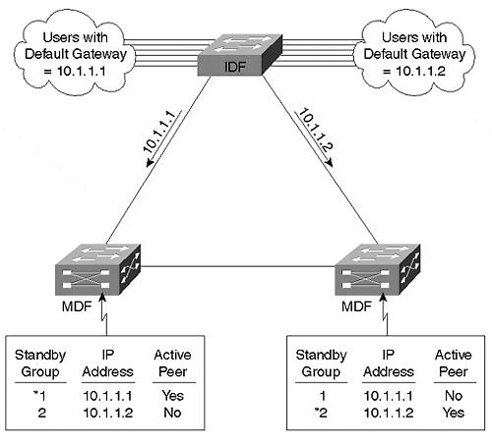
In Figure 14-10, two HSRP groups are created for a single subnet/VLAN. The first group uses the address 10.1.1.1, whereas the second group uses 10.1.1.2. Notice that both addresses intentionally fall within the same subnet. Half of the end stations connected to the IDF switch are then configured to use a primary default gateway of 10.1.1.1, and the other half use 10.1.1.2 (this can be automated with DHCP). For more information on this technique, see the "MHSRP" section of Chapter 11 and the "Use DHCP to Solve User Mobility Problems" section of Chapter 15.
Tip
In general, implementing load balancing while using switching routers in the distribution layer requires multiple IDF VLANs (each with a separate HSRP standby group) or MHSRP for a single IDF VLAN.

Routing Services (MLS) MDFs
However, if the MDF switches are using routing switch MLS-style Layer 3 switching, the design might be very different. In this case, it is entirely possible to have Layer 2 loops. Rather than being pure routers as with the switching router approach, the MDF switches are normal Layer 2 devices that have been enhanced with Layer 3 caching technology. Therefore, MLS devices pass Layer 2 traffic by default (this default can be changed). For example, Figure 14-11 illustrates the Layer 2 loops that commonly result when MLS is in use.

Figure 14-11 MLS Often Creates Layer 2 Loops that Require STP Load Balancing
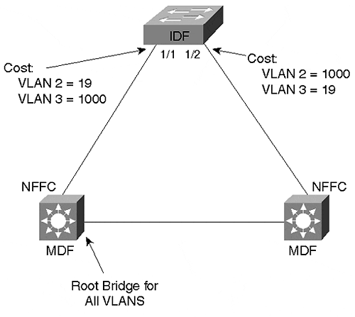
Both VLANs 2 and 3 are assigned to all three trunk links, forming a Layer 2 loop. In this case, STP load balancing is required. As shown in Figure 14-11, the cost for VLAN 3 on the 1/1 IDF port can be increased to 1000, and the same can be done for VLAN 2 on Port 1/2. For more detailed information on STP load balancing, please see Chapter 7.
Tip
The Layer 2/3 hybrid nature of MLS generally requires STP load balancing.

Core
Designing the core of a multilayer network is one of the areas where creativity and careful planning can come into play. Unlike the distribution blocks, there is no set design for a multilayer core. This section discusses some of the design factors that should be taken into consideration.
One of the primary concerns when designing a campus core backbone should be fast failover and convergence behavior. Because of the reliance on Layer 3 processing in the MLS design, fast-converging routing protocols can be used instead of the slower Spanning-Tree Protocol. However, one must be careful to avoid unexpected Spanning Tree slowdowns within the core itself.
Another concern is that of VLANs. In some cases, the core can utilize a single flat VLAN that spans one or more Layer 2 core switches. In other cases, traffic can be segregated into VLANs for a variety of reasons. For example, multiple VLANs can be used for policy reasons or to separate the different Layer 3 protocols. A separate management VLAN is also desirable when using Layer 2-oriented switches.
Broadcast and multicast traffic are other areas of concern. As much as possible, broadcasts should be kept off of the network's core. Because the multilayer model uses Layer 3 switching in the MDF devices, this usually isn't an issue. Likewise, multicast traffic also benefits from the use of routers in the multilayer model. If the core makes use of routing, Protocol Independent Multicast (PIM) can be used to dynamically build optimized multicast distribution trees. If sparse-mode PIM is used, the rendezvous point (RP) can be placed on a Layer 3 switch in the core. If the core is comprised of Layer 2 switches only, then CGMP or IGMP Snooping can be deployed to reduce multicast flooding within the core.
One of the important decisions facing every campus network designer has to do with the choice of media and switching technology. The majority of campus networks currently utilize Fast and Gigabit Ethernet within the core. However, ATM can be a viable choice in many cases. Because it supports a wide range of services, can integrate well with wide area networks, and provides extremely low-latency switching, ATM has many appealing aspects. Also, MultiProtocol Label Swapping (MPLS, also known as Tag Switching), traditionally seen as a WAN-only technology, is likely to become increasingly common in very large campus backbones. Because it provides excellent traffic engineering capabilities and very tight integration between Layer 2 and 3, MPLS can be extremely useful in all sorts of network designs.
However, the most critical decision has to do with the switching characteristics of the core. In some cases, a Layer 2 core is optimal; other networks benefit from a Layer 3 core. The following sections discuss issues particular to each.

Layer 2 Core
Figure 14-12 depicts the typical Layer 2 core in a multilayer network.

Figure 14-12 A Layer 2 Core
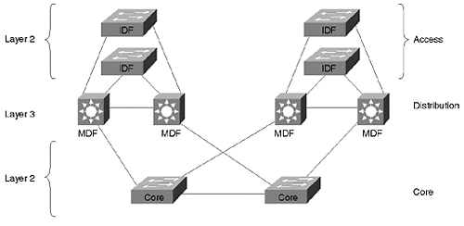
This creates a L2/L3/L2 profile throughout the network. The network's intelligence is contained in the distribution-layer MDF switches. Both the access (IDF) and core switches utilize Layer 2 switching to maintain a high price/performance ratio. To provide redundancy, a pair of switches form the core. Because the core uses Layer 2 processing, this approach is most suitable for small to medium campus backbones.
When building a Layer 2 core, Spanning Tree failover performance should be closely analyzed. Otherwise, the entire network can suffer from excessively slow reconvergence. Because the equipment comprising the campus core should be housed in tightly controlled locations, it is often desirable to disable Spanning Tree entirely within the core of the network.
Tip
I recommend that you only disable Spanning Tree in the core if you are using switching routers in the distribution layer. If MLS is in use, its Layer 2 orientation makes it too easy to misconfigure a distribution switch and create a bridging loop.

One way to accomplish this is through the use of multiple VLANs that have been carefully assigned to links in a manner that create a loop-free topology within each VLAN. An alternate approach consists of physically removing cables that create Layer 2 loops. For example, consider Figure 14-13.

Figure 14-13 A Loop-Free Core
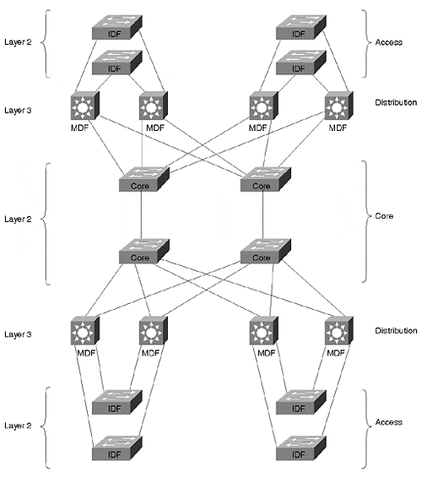
In Figure 14-13, the four Layer 2 switches forming the core have been kept loop free at Layer 2. Although a redundant path does exist through each distribution (MDF) switch, the pure routing behavior of these nodes prevents any Layer 2 loops from forming.
If Spanning Tree is required within the core, blocked ports should be closely analyzed. Because STP load balancing can be very tricky to implement in the network core, compromises might be necessary.
In addition to Spanning Tree, there are several other issues to look for in a Layer 2 core. First, be careful that multicast flooding is not a problem. As mentioned earlier, IGMP Snooping and CGMP can be useful tools in this situation (also see Chapter 13). Second, keep an eye on router peering limits as the network grows. Because each MDF switch is a router under the multilayer model, a Layer 2 core creates the appearance of many routers sitting around a single subnet. If the number of routers becomes too large, this can easily lead to excessive state information, erratic behavior, and slow convergence. In this case, it can be desirable to break the network into multiple VLANs that reduce peering.
Tip
Be careful to avoid excessive router peering when using Catalyst 8500s. One of the easiest ways to accomplish this is through the use of a Layer 3 core (see the next section).

A Layer 2 core can provide a very useful campus backbone. However, because of the potential issues and scaling limits, it is most appropriate in small to medium campus networks.
Tip
A Layer 2 core can be a cost-effective solution for smaller campus networks.

Layer 3 Core
Figure 14-14 redraws Figure 14-12 with a Layer 3 core.

Figure 14-14 A Layer 3 Core
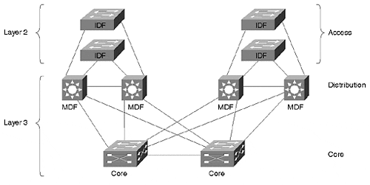
Although Figure 14-12 and Figure 14-14 look very similar, the use of Layer 3 switching within the core makes several important changes to the network.
First, the path determination is no longer contained only within the distribution layer switches. With a Layer 3 core, the path determination is spread throughout the distribution and core layer switches. This more decentralized approach can provide many benefits:
- Higher aggregate forwarding capacity
- Superior multicast control
- Flexible and easy to configure load balancing
- Scalability
- Router peering is reduced
- IOS feature throughout a large percentage of the network
In short, the power and flexibility of Layer 3 processing eliminates many of the issues discussed concerning Layer 2 backbones. For example, the switches can be connected in a wide variety of looped configurations without concern for bridging loops or STP performance. By cross-linking core switches, redundancy and performance can be maximized. Also, placing routing nodes within campus core, router mesh and peering between the distribution switches can be dramatically reduced (however, it is still advisable to consider areas of excessive router peering).
Notice that a Layer 3 core does add additional hops to the path of most traffic. In the case of a Layer 2 core, most traffic requires two hops, one through the end user's MDF switch and the other through the server farm's MDF switch. In the case of a Layer 3 core, an additional hop (or two) is added. However, several factors minimize this concern:
- The consistent and modular design of the multilayer model guarantees a consistent and small number of router hops. In general, no more than four router hops within the campus should ever be necessary.
- Many Layer 3 switches have latencies comparable to Layer 2 switches.
- Windowing protocols (such as TCP or IPX Burst Mode) reduce impact of latency for most applications.
- Switching latency is often a very small part of overall latency. In other words, latency is not as big an issue as most people make it out to be.
- The scalability benefits of Layer 3 are generally far more important than any latency concerns.
Tip
Larger campus networks benefit from a Layer 3 core.

Server Farm Design
Server farm design is an important part of almost all modern networks. The multilayer model easily accommodates this requirement. First, the server farm can easily be treated as its own distribution block. A pair of redundant Layer 3 switches can be used to provide physical redundancy as well as network layer redundancy with protocols such as HSRP. In addition, the Layer 3 switches create an ideal place to apply server-related policy and access lists. Figure 14-15 illustrates a server farm distribution block.

Figure 14-15 The Server Farm Can Form Another Distribution Block
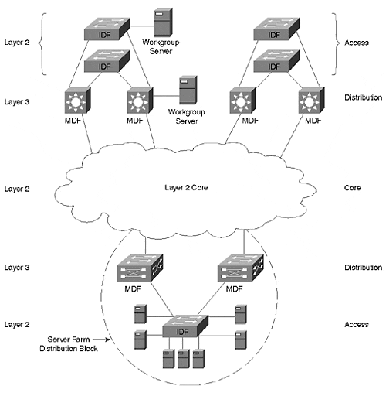
Although enterprise-wide servers should generally be deployed in a central location, workgroup servers can be attached directly to access or distribution level switches. Two examples of this are shown in Figure 14-15.
Tip
An enterprise server farm is usually best implemented as another distribution block that connects to the core.

Specific tips for server farm design are discussed in considerably more detail in the "Server Farms" section of Chapter 15.

Using a Unique VTP Domain for Each Distribution Block
When using the MLS approach to Layer 3 switching in the MDF closets, it might be advantageous to make each distribution block a separate VTP domain. Because of the Layer 2 orientation to MLS, VLANs propagate throughout the entire network by default (see Chapter 12 for more information on VTP). However, the multilayer model is designed to constrain VLANs to an individual distribution block. By innocently using the default behavior, your network can become unnecessarily burdened by extraneous VLANs and STP computations.
Assigning a unique VTP domain name to each distribution block is a simple but effective way to have VLAN propagation mirror the intended design. When a new VLAN is added within a distribution block, it automatically is added to every other switch in that block. However, because other distribution blocks are using a different domain name, they do not learn about this new VLAN.
Tip
The MLS approach to Layer 3 switching can lead to excessive VLAN propagation. Use a different VTP domain name for each distribution block to overcome this default behavior.

When VTP domains are in use, it is usually best to make the names descriptive of the distribution block (for example, Building1 and Building 2).
Tip
Recall from Chapter 8 that when using trunk links between different VTP domains, the trunk state will need to be hard-coded to on. The use of auto and desirable will not work across VTP domain names (in other words, the DISL and DTP protocols check for matching VTP domain names).

IP Addressing
In a very large campus network, it is usually best to assign bitwise contiguous blocks of address spaces to each distribution block. This allows the routers in each distribution block to summarize all of the subnets within that block into a single advertisement that gets sent into the core backbone. For example, the single advertisement 10.1.16.0/20 (/20 is a shorthand way to represent the subnet mask 255.255.240.0) can summarize the entire range of 16 subnets from 10.1.16.0/24 to 10.1.31.0/24 (/24 is equivalent to the subnet mask 255.255.255.0). This is illustrated in Figure 14-16.

Figure 14-16 Using IP Address Summarization
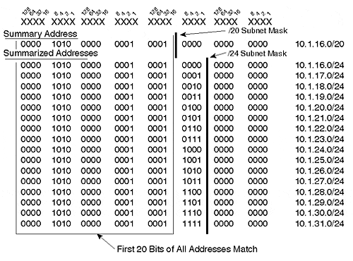
As shown in Figure 14-16, the /20 and /24 subnet masks (or network prefixes) differ by four bits (in other words, /20 is four bits "shorter" than /24). These are the only four bits that differ between the 16 /24 subnet addresses. In other words, because all 16 /24 subnet addresses match in the first 20 bits, a single /20 address can be used to summarize all of them.
In a real-world distribution block, the 16 individual /24 subnets can be applied to 16 different end-user VLANs. However, outside the distribution block, a classless IP routing protocol can distribute the single /20 route of 10.1.16.0/20.
Tip
In very large campus networks, try to plan for future growth and address summarization by pre-allocating bitwise contiguous blocks of address space.

Scaling Link Bandwidth
Note that the modular nature of the multilayer model allows individual links to easily scale to higher bandwidth. Not only does the architecture accommodate entirely different media types, it is easy to add additional links and utilize Fast or Gigabit EtherChannel.

Network Migrations
Finally, the modularity of the multilayer model can make migrations much easier. In general, the entire old network can appear as a single distribution block to the rest of the new network (for example, imagine that the server farm distribution block in Figure 14-15 is the old network). Although the old network generally does not have all of the benefits of the multilayer model, it provides a redundant and routed linkage between the two networks. After the migration is complete, the old network can be disabled.

Exercises
This section includes a variety of questions on the topic of this chapter—campus design concepts and models. By completing these, you can test your mastery of the material included in this chapter as well as help prepare yourself for the CCIE written and lab tests.

Review Questions
1: | What are some of the unique requirements of an IDF switch?
2: | What are some of the unique requirements of an MDF switch?
3: | Describe the access/distribution/core terminology.
4: | Why is routing an important part of any large network design?
5: | What networks work best with the router and hub model?
6: | What are the benefits of the campus-wide VLANs model?
7: | What are the downsides of the campus-wide VLANs model?
8: | Describe the concept of a distribution block.
9: | Why is it important to have modularity in a network?
10: | What are the concerns that arise when using a Layer 2 core versus a Layer 3 core?
11: | How should a server farm be implemented in the multilayer model?

Design Lab
Q: | Design two campus networks that meet the following requirements. The first design should employ the campus-wide VLANs model using Catalyst 5509 switches. The second design should implement the multilayer model by using Catalyst 8540 MDF switches and Catalyst 5509 IDF switches. Here are the requirements:  - The campus contains three buildings.  - Each building has four floors.  - Each floor has one IDF switch. (In reality there would be more, however, these can be eliminated from this exercise for simplicity.)  - Each building has two MDF switches in the basement.  - Each IDF has redundant links (one two each MDF switch).  - The MDF switches are fully or partially meshed (choose which one you feel is more appropriate) with Gigabit Ethernet links (in other words, the core does not use a third layer of switches).  - Each IDF switch should have a unique management VLAN where SC0 can be assigned.  - In the campus-wide VLANs design, assume there are 12 VLANs and that every IDF switch participates in every VLAN.  - In the multilayer design, assume that every IDF switch only participates in a single end-user VLAN (for administrative simplicity).  How many VLANs are required under both designs?

